|  |
| --- |
|  |
| Media Organiser  Design documentation |
| |  |  |  | | --- | --- | --- | | Harry Wigman | 15/4/2019 | Project A – Media Organiser | |

# Outline

The Media Organiser is a standalone component which will support the organisation of media files on desktop computers. The component will support a range of video and audio files located on the users local file system. During runtime the component will be able to change it’s scope, save it’s state and manage files.

# Designs

There are three primary areas of the application (with variations or additional sub-sections for other functionality).   
  
**Main menu** – Navigation to search and edit user created lists.

**Search views** – Search functionality with three variations for different options.

**Edit lists** – Edit both playlists and categories available

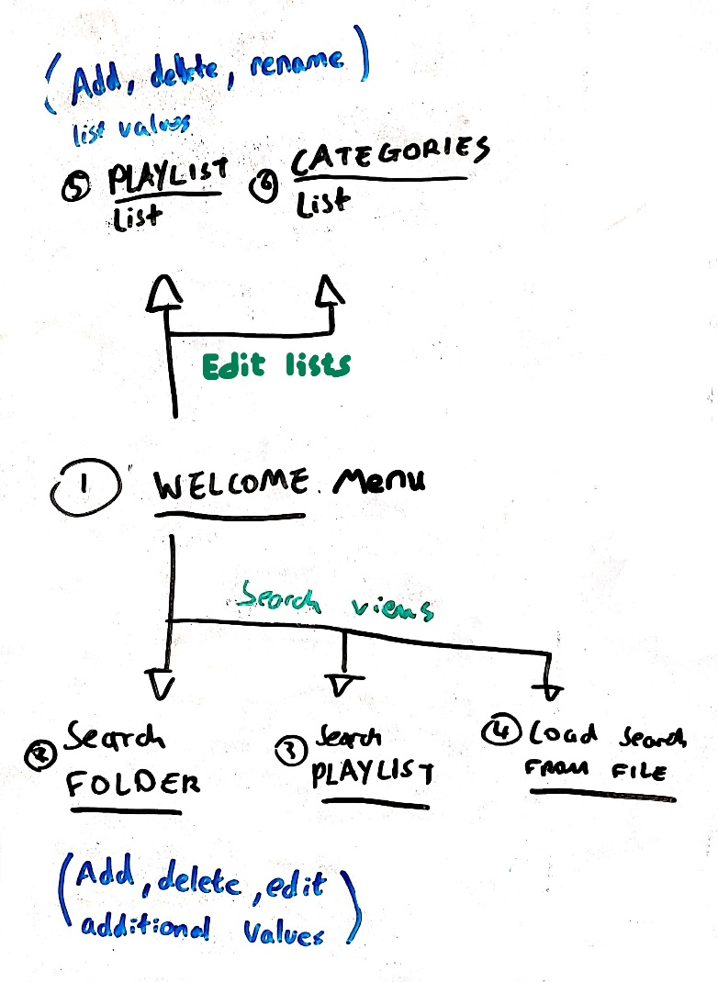

[Flow diagram of the applications areas]

See the following PDF files to see the UI designs:

* Menu (and search preference views)  
  
* Edit lists (and the renaming entry view)  
  
* Search views  
  
* Edit file  
  

# Expected functionality

From the requirements I have listed my assumptions on the expected functionality:

## Media file types

The application will be able to support the following media file extensions:

**Audio**

* FLAC
* OGG
* AAC
* MP3
* WAV

**Video**

* AVI
* MP4
* MOV
* WMV
* MKV

## Search

The user can search media files in three key ways

* Folder (Search files inside a folder from a set file path on the system)
* Playlist (Search files contained within a user created playlist)
* File (From a generated State file, search from a state of previous search preference)

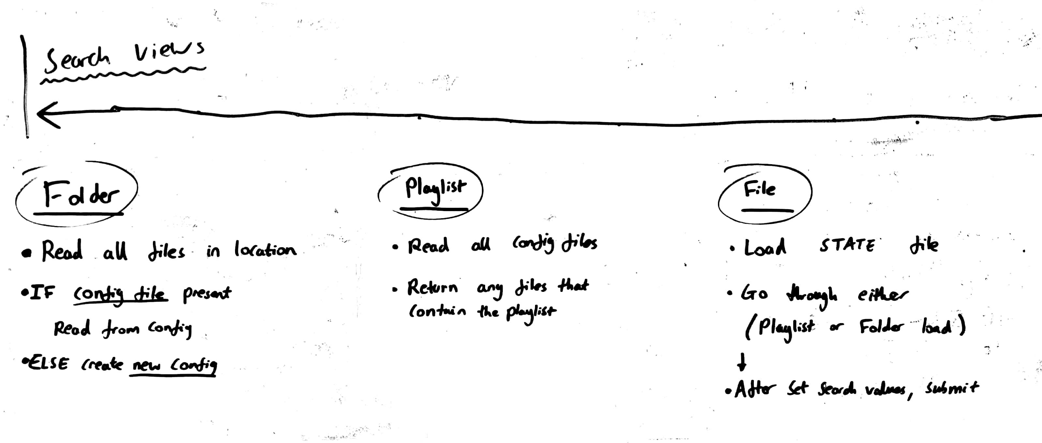  
[Base functionality of each search type]

During a search the user can also refine the criteria further with Title and Extension filters.

### Save search

During any search the user can save the state of the applications search to a portable State file.

## Media information

The user can manage a media files related information once selected during a search. The following will be fields the user can Add, delete and edit:

* Picture (Will link to any available image with the same name in the picture folder)
* Categories (None, one or multiple user created categories)
* Playlists (None, one or multiple user created playlists)
* Comment (Text of any length, can’t contain a semicolon ‘;’)

## Lists

The user can edit the list of Categories and Playlists. Each entry in the separate lists can be added, deleted and edited.

# Application files

There are three files the application creates to serve different functionality.

* **Configuration file**Store data for each media file the application can search/view.

|  |
| --- |
| **FILE, EXTENSION, PATH, PICTURE, CATEGORIES, PLAYLISTS, COMMENTS** jungle;mp4;C:\data;tree;cat1,cat2;play1#12,play2#32;example |

* **State file**When a search is saved, it will store the state of the application(Not all fields must be set)

|  |
| --- |
| **FOLDER, PLAYLIST, TITLE, EXTENSION** C:\data;;;mp3 OR  ;play1;example;mp4 |

* **List file**Used for both playlists and categories, lists out every entry for both.

|  |
| --- |
| **Entries**  play1,play2 |

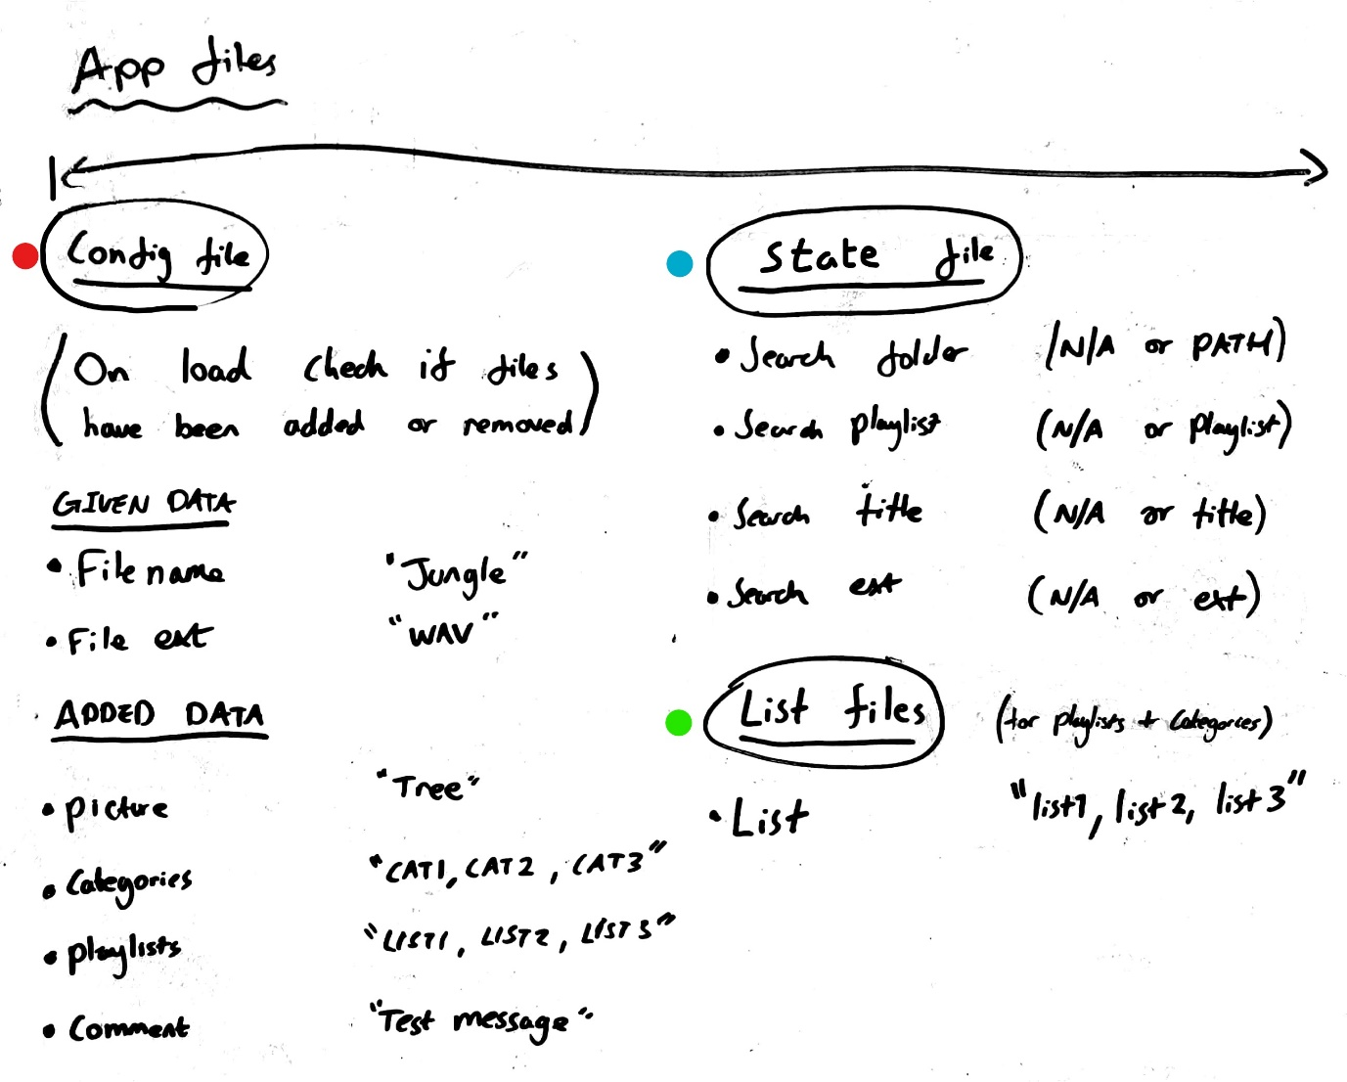

[Description of the data held in each application file]

The application will have the following folders and files in its root directory:

Pictures, MediaOrganiser.exe, config.txt, categories.txt, playlists.txt